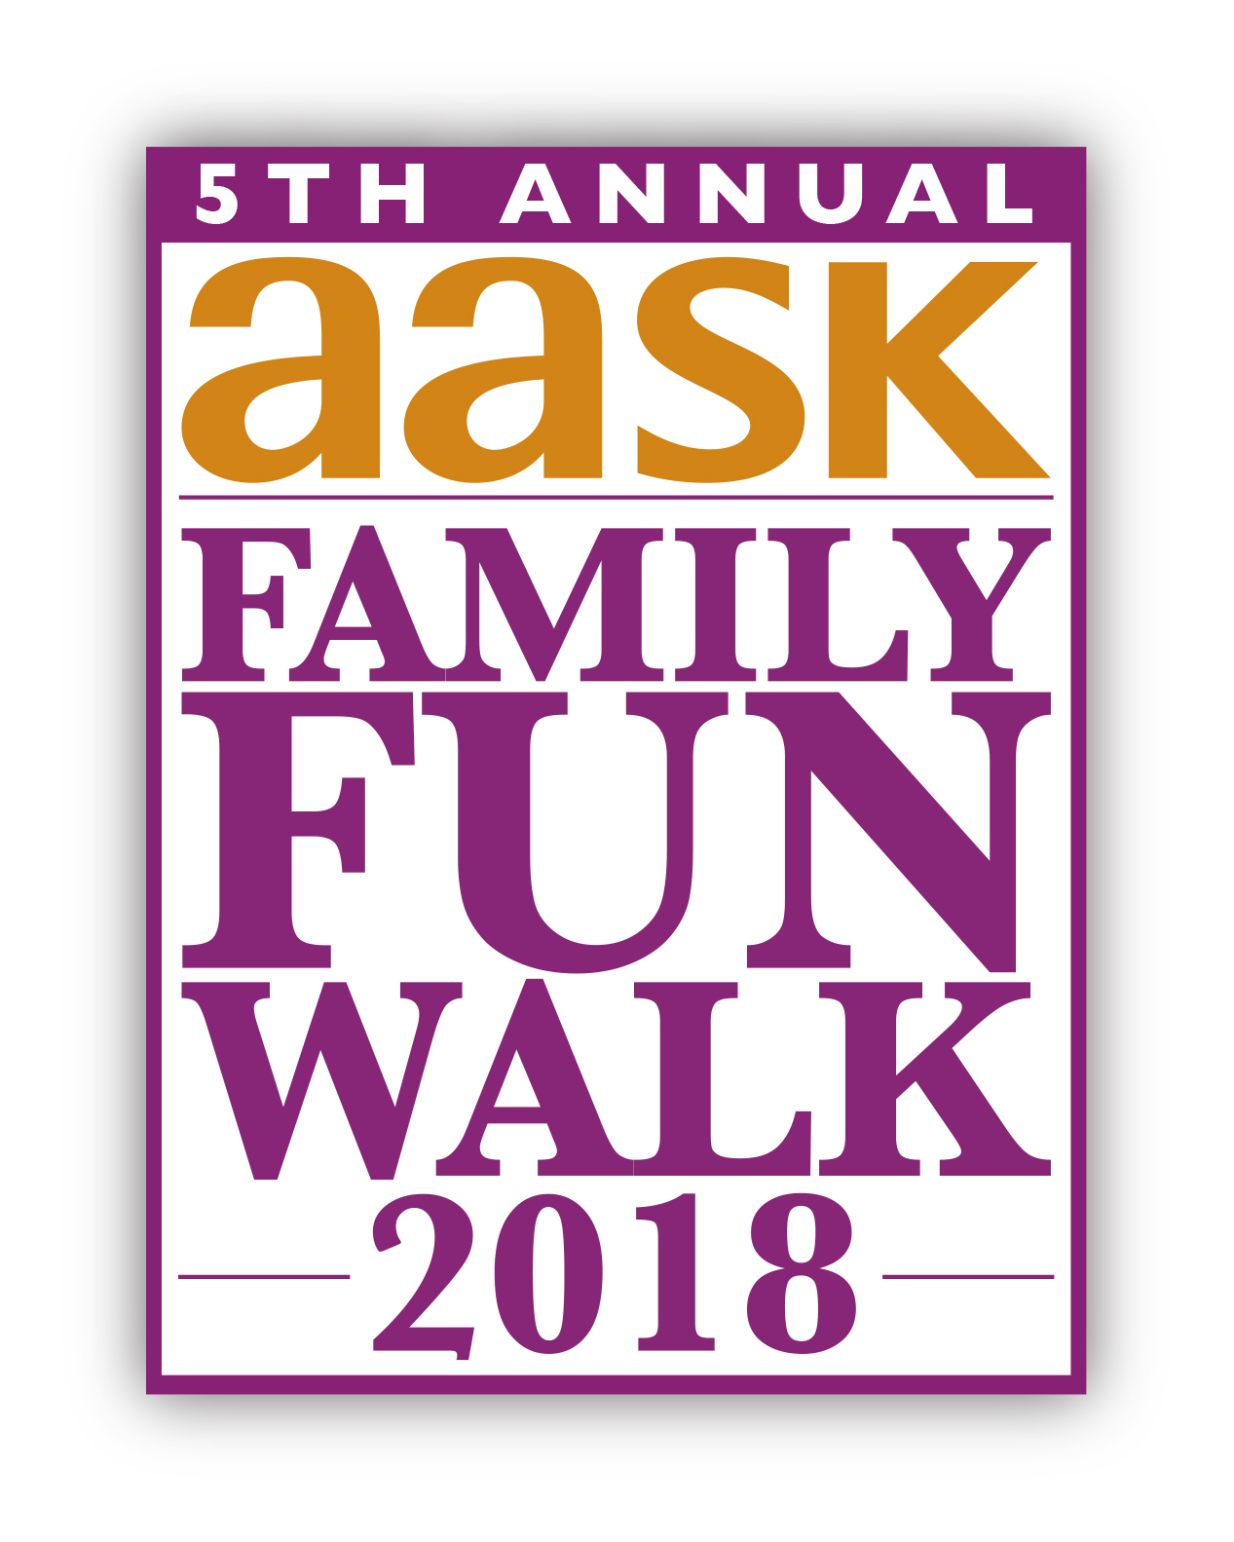

Team Captain Kit
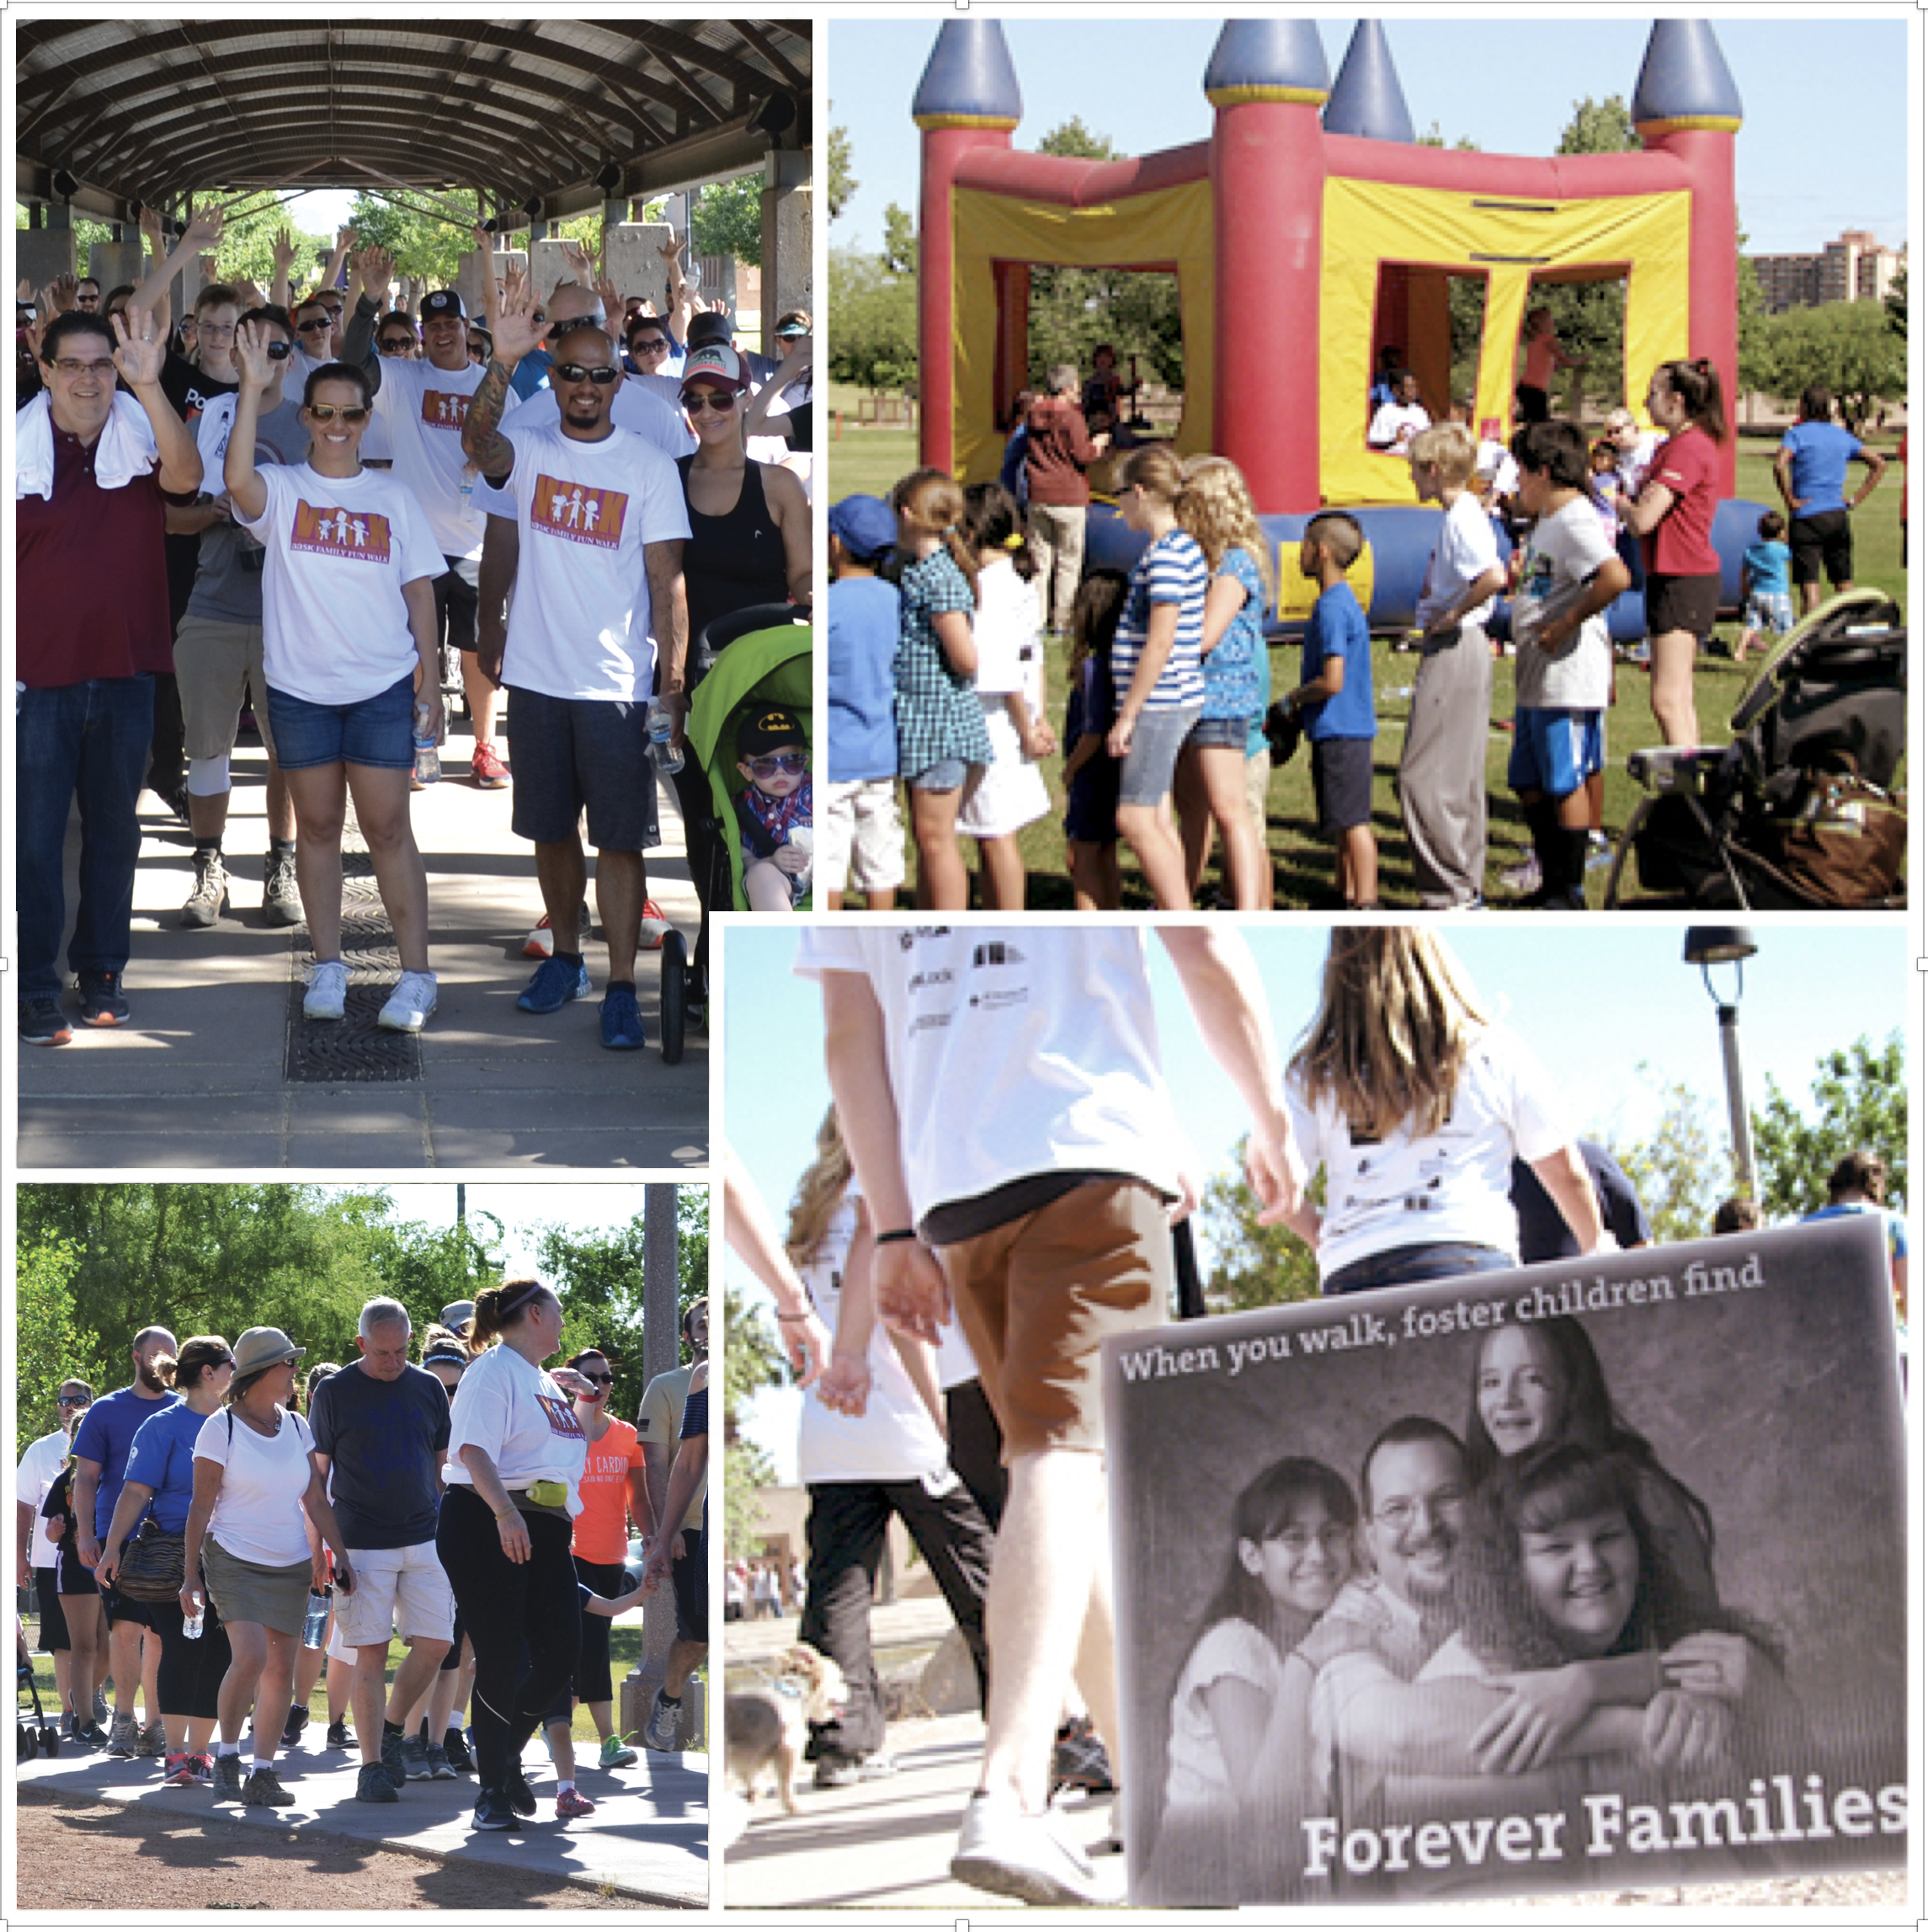

Table of Contents:

Welcome Letter 3
Event Info 4
Individual Incentives 5
Team Fundraising Ideas 6
Third Party Event Guidelines 8
Sample Solicitation Letter 9
AASK 501(c)(3) Letter 10
Map of Steele Indian School Park 11
Materials Order Form 12

Questions?

Please contact Jackie Palmenberg
At 602-930-4452, or email jpalmenberg@aask-az.org.
Dear Team Captain,

Thank you for forming a team for the Fifth Annual AASK Family Fun Walk!

Since 1988, Aid to Adoption of Special Kids (AASK) has created lasting and permanent relationships for children in foster care.

Arizona has over 16,500 children in foster care, and with your help, AASK will continue to connect children with foster families, adoptive families, kin, siblings, and adult mentors.

AASK raises funds because children in foster care need consistent, healthy, and loving relationships. Here are examples of what Walk fundraising will do:

- Help reunite siblings separated by foster care.
AASK offers activities year round that reunite separated siblings, and hosts a Siblings Summer Camp in Payson every June, where brothers and sisters spend a full week together as family.

- Provide adult mentors for children in group homes and shelters.
Arizona’s shortage of foster families means that more and more children end up in group homes/shelters. AASK’s Mentoring Program matches caring adult mentors in 1:1 relationships with children living in these congregate care settings.

- Help kinship families who care for the children of relatives.
Grandparents, aunts and uncles often step forward to care for the children of relatives, but may face financial and other hardships, as well as being unprepared. AASK provides free services and support for these families, even before licensing, to help them succeed.

On behalf of every AASK family, thank you again for forming a team, taking this journey to raise funds for foster care, and walking with us on May 5.

Sincerely,
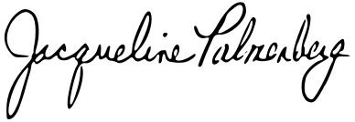
Jacqueline Palmenberg, CFRE
Development Lead

For more information about becoming a foster parent or mentor, please visit www.aaak-az.org
Event Info

The AASK Walk Kickoff is a free lunch and information meeting for anyone interested in learning more! About the Walk, about AASK, about children in foster care….and the good that your fundraising will do. Team captains and individual participants can also pick up extra fundraising supplies such as brochures, flyers, and walker envelopes.

Kick-Off Luncheon
Wednesday, March 7, 2018
11:30 AM – 1:00 PM
2320 North 20th Street, Phoenix
Luncheon hosted by Poncho’s Familia.

The AASK Family Fun Walk is a 1.5 mile walk through the park – strollers, wagons, wheelchairs, pets welcome! Beginning and ending in our expo area, families will enjoy music, food, games and activities for children of all ages.

AASK Family Fun Walk – 5th Anniversary
Saturday, May 5, 2018
7:30am – Registration & Check-in
8:00am-10:30am – Walk Program
Steele Indian School Park
Phoenix Green Area
300 E. Indian School Road, Phoenix
(enter off 7th Street)

The Walk Recognition Luncheon is a wrap-up celebration in late June, hosted by AASK, where we share fundraising results and say THANK YOU to our sponsors, top fundraisers, committee members and key volunteers. Any individual who raises $1,500 or more, and any team that raises $5,000 or more, will receive an invitation late May. Hope to see you there!

Raise: | You will receive:
$35 | Walk T-Shirt
 | If
If the $35 is received by
noon May 4, t-shirts
will be available at the Walk.
If received on May 5,
shirts will be ordered post-Walk,
for later distribution.
$1,500+,  as individual | Invitation to WALK Recognition Event
Funds will be collected through
May 31, 2018, to qualify for the
WALK Recognition invitation in June.

$5,000+,  as Team | Invitation to WALK Recognition Event


Team Fundraising Ideas

This is where you can REALLY have fun….and put the “FUN” in ‘fun’draising.

Besides the events listed in the box below, this manual provides just a few examples of the many restaurants which have fund raising opportunities and how to go about doing one.
Bake Sales  Silent Auction  Candy Grams  Pie in the Face Day  Coffee Cart  Yard Sale | Lunch Delivery  Balloon Pops  Salsa Contest  Store Percentage Days  Car Wash  Pancake Breakfast

- Macayo’s Mexican Kitchen: All you have to do to schedule a Macayo’s Benefit Night is to contact your neighborhood restaurant. After setting the date, they will design the invitation for you to distribute to your friends and family. The flyer is presented to their server on that date, and the charity receives 20% of sales.

- Oregano’s: At oreganos.com/family/giving-back/, you’ll see Gibbilini Givebacks (after the family who founded Oregano’s). A pdf of the Request Form (which must be received 6 weeks prior to your requested date) is available; they also need a W9 for AASK, which Jackie can provide to you (602-930-4452). Similar to Macayo’s, they supply “a groovy marketing piece” to print and distribute. On the specified date, they’ll donate 20% of the participating guests’ check proceeds (take-out included!). Again, the flyer MUST accompany the purchase. To schedule a Gibbilini Giveback Day, contact guestservices@oreganos.com.

- Peter Piper Pizza: They donate 15% of food, non-alcoholic beverages, and game tokens purchased by your group (pre-tax). Register your preferred date and time at http://www.peterpiperpizza.com/community/post/1218/208/PPI/. You’ll be emailed a customized fundraising flyer to use, along with ‘free token’ coupons, to encourage maximum enthusiasm for the children. “Fundraiser Tonight” banner will also be included. Must show flyer at register to get credit for purchases.


OFFICE FUNDRAISERS ARE GREAT…try these:
50/50 Raffle: sell tickets for a few days, select winner; they get half the cash and half goes to the Walk Team fundraising.

Ice Cream Social: host this in the break room and ask your company’s leader(s) to serve the ice cream to employees who donate.

Jeans Day: work with your company to arrange a day where employees who make a certain donation are allowed to wear jeans.

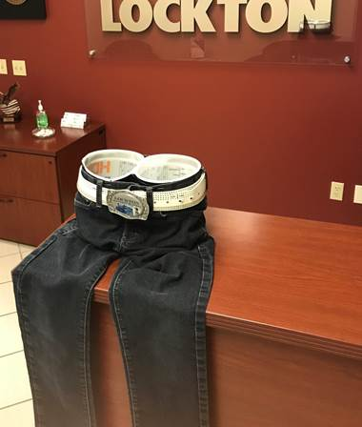

Third Party Event Guidelines

A third party event is a fundraiser (e.g. golf tournament, pancake breakfast, or auction) that is planned, organized, and executed entirely by volunteers acting on behalf of AASK.

AASK staff may play an advisory role but are not responsible for event logistics or expenses that might be incurred. AASK receives event proceeds (after expenses) as a donation.

Here are some guidelines to consider:

- Third party events must be in line with our mission.

- The use of our logo and name on any promotional materials (e.g., press releases, fliers, invitations, websites, letters, etc.) must be reviewed and approved by a staff member to verify accuracy.

- AASK must receive a list of targeted sponsors for the event before they are approached to minimize any overlap with other AASK events and/or fundraising requests that may be underway.

- To protect our donors’ privacy, AASK will not provide donor or sponsor lists, nor will we solicit sponsorship for third party fundraising events.

- Event organizers are responsible for obtaining all permits and liability waivers

- Event organizers must obtain their own liability insurance to cover the event.

- AASK is not financially liable for the promotion, planning or execution of third party events.

- We request that you provide us the event proceeds within 30 days after the conclusion of the special event/fundraiser.

If you are interested in planning a third party event, please contact Jackie Palmenberg at jpalmenberg@aask-az.org or 602-930-4452 to request an Event Agreement form.

Thank you!
Sample Solicitation Letter

Name
Address
City, State Zip Code
Date
Dear (First Name),

Today I am making a difference for children in Arizona’s foster care system, by participating in the AASK Family Fun Walk. We are walking May 5, 2018, and I have committed to raise $_________ for Team ____________.

Funds raised will help AASK find families and mentors for children in foster care, and strengthen the ties among siblings separated by the foster care system.

Children enter foster care due to abuse, abandonment, and neglect, and a lifetime of disappointing relationships. By raising needed funds I am helping AASK to ensure that every child has someone who cares.

Please help me reach my goal by making a donation of $________. You can donate securely online through my personal fundraising page (www.webpage here) or send a check (payable to AASK) to the following address:

Aid to Adoption of Special Kids (AASK)
AASK Family Fun Walk
2320 N. 20th Street
Phoenix, AZ 85006

Please note my name and Walk team in the memo line.

Thank you for considering my request, and helping to change the life of a child.

Sincerely,

AASK Walk Team Captain

Aid to Adoption of Special Kids (AASK) is a 501(c)(3) nonprofit organization
Tax ID # 86-0611935
AASK 501(c)(3) Letter

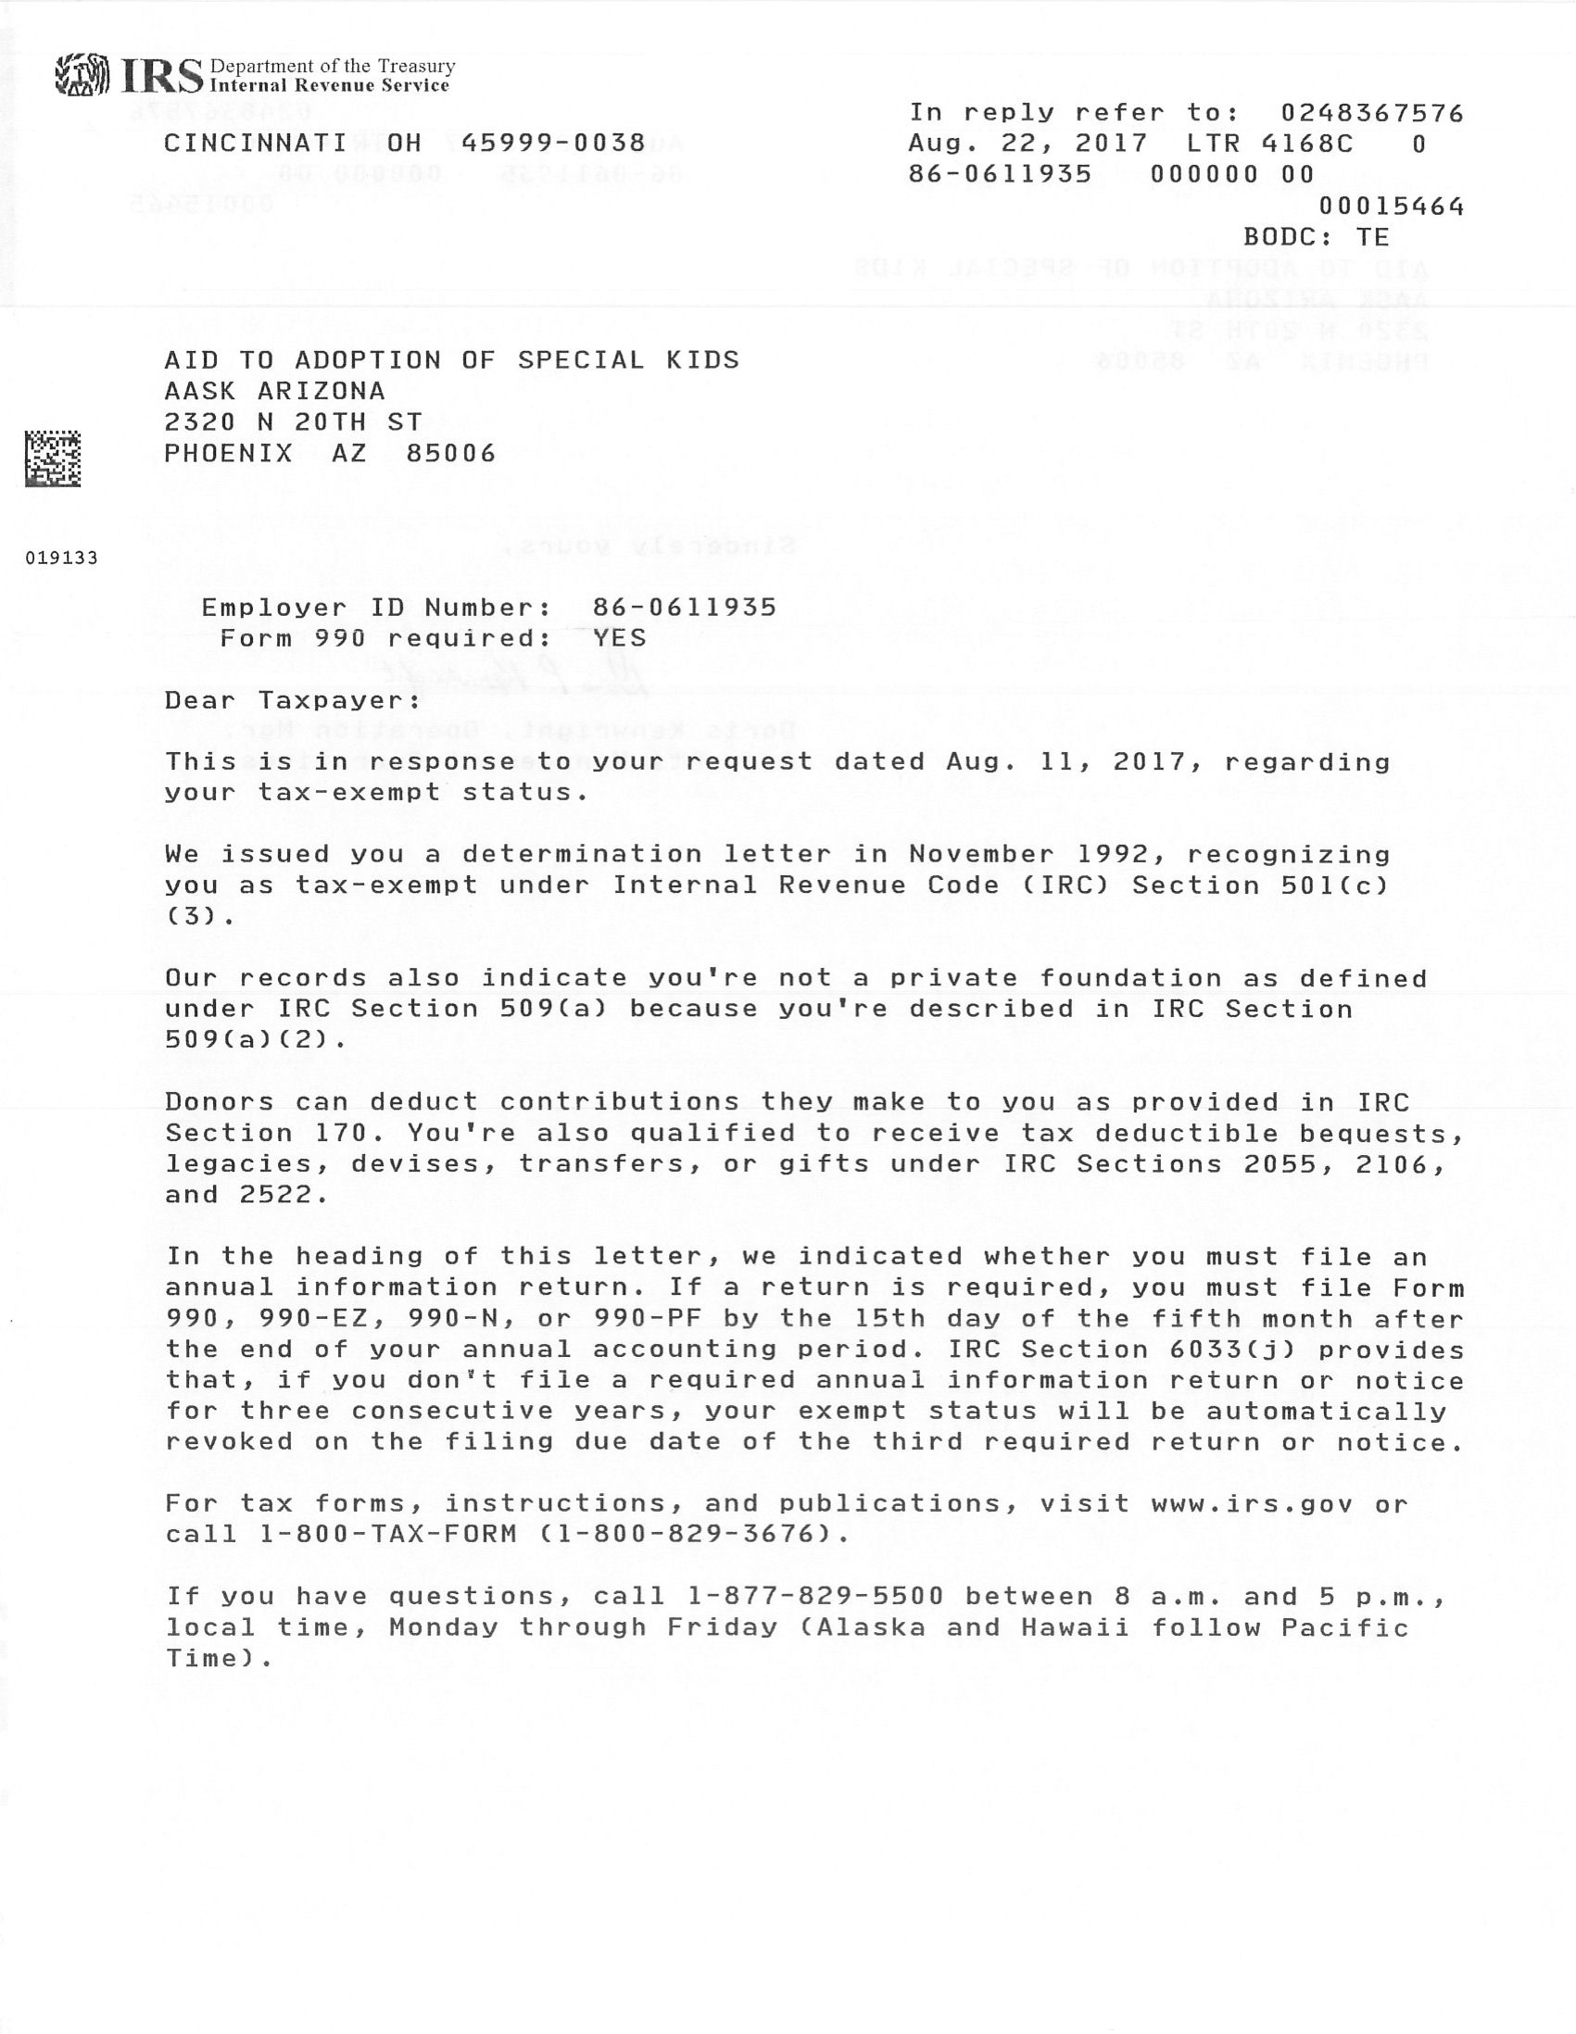
Map for Walk

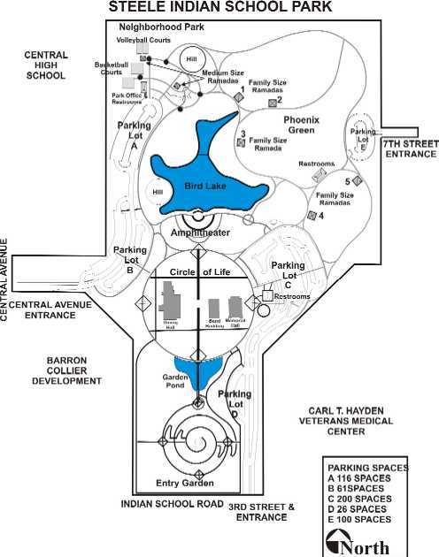

✰
✰ Walk Day May 5



Materials Order Form

The following Walk materials are available to help you grow your team, promote the Walk, and achieve your fundraising goals!

Item | Quantity
Walk Brochures
Walk Brochure Holder(s)
Walk Flyers
Walker Donation-Collection Envelope(s)
Donation Receipts

Your Name ________________________________Date ________________

Team Name ____________________________________________________

Mailing Address _________________________________________________

______________________________________________________________

Phone _________________________________________________________

Email __________________________________________________________

To place an order, please fill out this form and return by email to Jackie Palmenberg at jpalmenberg@aask-az.org or call 602-930-4452.

